

A Frenetic First-Person Shooter (FFPS)

Game Design Document
Version 1.0
Produced by Dylan Blereau, Bryce Standley, and Christopher Logan
Created: February 26, 2021


Table of Contents
Contents
Game Overview 4
Philosophy 4
Philosophical point #1 4
Philosophical point #2 4
Philosophical point #3 4
Common Questions 4
What is the game? 4
Why create this game? 4
Where does the game take place? 4
What do I control? 5
How many characters do I control? 5
Who is the target demographic? 5
What is the main focus? 5
What’s different? 5
Feature Set 6
General Features 6
Implemented Features 6
Not Yet Implemented Features 6
Editor 6
Gameplay 6
The Game World 8
Overview 8
Key Locations 8
Travel 8
Scale 8
Objects 8
Weather 8
Day and Night 8
Time 8
Rendering System 8
Overview 8
2D/3D Rendering 9
Camera 9
Overview 9
Camera Detail #1 9
Camera Detail #2 9
Game Engine 9
Overview 9
Game Engine Detail #1 9
Water 9
Collision Detection 9
Lighting Models 9
The World Layout 11
Overview 11
World Layout Detail #1 – Randomly placed enemies 11
World Layout Detail #2 – Randomly placed furnishings 11
Game Characters 12
Overview 12
Creating a Character 12
Enemies and Monsters 12
User Interface 13
Main Menu Screen 13
Results Screen 13
Credits Screen 14
Controls Screen 15
Weapons 16
Overview 16
Weapons Details #1 16
Sound and Music 17
Overview 17
Sound Effects 17
Music 17
Single-Player Game 18
Story 18
Core Gameplay 18
Modes of Play 18
Attack Waves 18
Quick Rest 19
Scoring 19
Killing a Demon 19
Clearing a Wave 19
Collecting a Power-Up Token 19
Game Flow 19
Splash Screen 19
Main Menu Mode 20
Play Mode 20
Results Screen Mode 20
Credits Screen Mode 20
Power-Ups! 20
Gameplay Length 21
Victory Conditions 21
AI Features 21
World Editing 22
Overview 22
World Editing Detail #1 – Customisable Terrain! 22
World Editing Detail #2 – Customisable Skybox! 22
World Editing Detail #3 – Customisable Object Placement! 22
Extra Miscellaneous Stuff 23
Overview 23
Junk I am working on… 23
Bounding Boxes 23

Game Overview

Philosophy

Philosophical point #1

We aren’t intending for ZOOM to be the greatest game of all time, but we are hoping that the quality of our engine will see it received as a solid and enjoyable experience.

Philosophical point #2

We believe that our game should run on pretty much any computer with a graphics card. We don’t need crazy stylish graphics to the get the point of our game across, and we want as many people to give it a try as possible.

Philosophical point #3

We want to craft a game we are proud of as a team, with the final game to be the resultant product of each team members ideas. While one person may come up with the core ideas, each team members ideas will be considered and applied if the idea is well received.

Common Questions

What is the game?

ZOOM is a quick and addictive FPS that transports gamers back to early days of first-person shooters. It is heavily inspired by some of the first-person shooter genres most prominent games such as DOOM and QUAKE, with a little sprinkle of influence also coming from the Call of Duty franchises Zombies mode.

ZOOM seeks to take the fast-frantic FPS gameplay seen in DOOM and QUAKE and combine it with the wave-based gameplay loop of Call of Duty Zombies, ultimately creating an engaging and intense gameplay experience.

Why creates this game?

We wanted to create ZOOM as it was the amalgamation of all the games we love to play. First-Person Shooters are a genre we all have played through our formative years and we felt like making a game that cherry picked the elements from the games we liked would result in a game that is both fun to develop and play.

As a team, we also each had prior experience creating a game in the first-person perspective, which was another reason as to why we picked a first-person shooter.

Where does the game take place?

ZOOM takes place on a small but dangerous moon that has mysteriously appeared in the solar system, not too far from the Earth’s moon. The people of Earth grow increasingly anxious and suspicious of this new moon, but they continue to live out their everyday lives. A few days after the moon’s arrival, Demon’s start appearing around the globe, attacking civilians, and claiming Earth as property of the underworld. In retaliation to the attack on Earth by the Demons, the United Nations enlist the help of ZOOM Girl, a biological superhuman who they see as humanity’s only hope of eradicating the demonic spawn. ZOOM Girl is quickly sent to the Demon moon now known as the “Neighbour in the Night Sky” with a simple mission – kill as many Demons as you possibly can.

The “Neighbour in the Night Sky” planet is the only area in ZOOM.

What do I control?

ZOOM Girl is the protagonist of ZOOM. She is heavily inspired by the DOOM Guy from the DOOM franchise and is a tall and athletic woman that wears a giant metal suit. Because the game is from the first-person perspective of ZOOM Girl, you never actually physically get to see her, but the idea and look of the character is implied through the narrative.

How many characters do I control?

In ZOOM you only control ZOOM Girl. There are no plans for any further playable characters.

Who is the target demographic?

ZOOM is targeted towards gamers that enjoy fast and fluid movement and shooting in their first-person shooters. The gameplay will be what takes centre stage in this experience, but the graphics are no slouch either with its stylish low-poly aesthetic. ZOOM is a game for anyone that has enjoyed an FPS.

What is the focus?

The focus in ZOOM is simple. Kill as many Demons as you possibly can until you die. ZOOM Girl is equipped with a trusty shotgun that can turn any Demon in her path into minced meat, so the key to success in ZOOM is to use the epic weapon to kill as much hell spawn as you come, with the Demons attacking in waves.

What’s different?

Our game isn’t exactly too different from what currently exists on the market, as the game is clearly inspired by multiple titles that have graced the gaming sphere over recent years.

What does make ZOOM different though is the fact that the game takes ideas from various games and bundles them all into one solid experience. We feel that ZOOM is a successful combination of its inspirators, providing an overall experience that is new but familiar at the same time.

Feature Set

General Features

Big outdoor world
Multitextured Terrain complete with a detail map and lighting
3D graphics
Stylish Skybox
Randomly placed enemies and environment features (currently spawning 15)
Collision Detection with terrain and environment obstacles
Ability to pick up power-ups and kill demons by colliding with them (Gun will be incorporated into assignment 2 which will be used to kill the demons)

Implemented Features

Terrain exceeding in 1 square kilometer
Terrain had multitexturing, a detail map, lighting
15 Demon NPCs spawn on the map
First-person character walks along terrain and follows the ground level.
First-person character collides with obstacles in the environment like Trees, Rocks, and the Terrain when it is too steep. Also collides with the tokens and demons, which collects and kills them respectively
(Note: While we could’ve provided collisions that stops the player from collecting and killing the demons, we thought it was wise to demonstrate that our collision detection allows for items to be picked up/ killed)
Camera is positioned at centre of terrain and can be changed with WASD keys
Mouse controls allows the first-person camera perspective to look around

Not Yet Implemented Features

We implemented all features that were required. We do however still a.

Editor

While there is no traditional level editor available with TNAH (Team Names Are Hard) Engine, the engine allows for customization through lua scripts.

From using your own heightmaps to picking how many enemies/power ups/environment obstacles that you want to spawn and position on the map, the onus is on the player to customize the experience to their liking if they want to do so.

The controls and skybox can even be changed if the user wants via their respective scripts.

Even though there is no explicit level editor, the TNAH engine does provide users an easy and effective way to put their own spin on the game.

Gameplay

As this is intended to be a tech demo and not the final game, there isn’t a great deal in the way of actual gameplay. What you can however do in the tech demo is take in the surrounds of the map that you will be shotgunning demons in.

The demons that you will fighting in the final game are present on the map in a static fashion, with walking into them removing them from the play area. We thought we would show that our collisions can remove the Demons from the scene, with that collision to be attached to a bullet fired from a gun in the final game.

The power-up tokens that can be picked up to grant ZOOM Girl stat boosts are also present in the map, levitating and rotating in places around the map. Like the Demons, colliding into them will remove them from the map, simulating the act of picking up an upgrade token. While the tokens are currently only stylistic in the tech demo, we thought it would be cool to highlight that they are items of importance that can be collected throughout the final game.

Gameplay may be light in this tech demo build; however, we feel that the gameplay loop of ZOOM can easily be seen and envisioned by what we have shown off in this demo.

The Game World

Overview

The game world of ZOOM takes place on the mysterious moon known as the “Neighbour in the Night Sky”. It is a relatively small moon that houses hellish demons.

Key Locations

The key location of ZOOM is the “Neighbour in the Night Sky” moon. It is the only place of interest in ZOOM.

Travel

The protagonist ZOOM Girl makes her way across the map zooming at a quick pace.

Scale

The scale of ZOOM is meant to mimic real life. ZOOM Girl is a similar size to the demons as seen by the first-person perspective, while the moon features trees and rocks that are again scaled as you’d expect them to be in the real world.

Objects

The following objects make up the world of ZOOM.

- Trees (Red, Green, Yellow)
- Rocks
- Power-Up Tokens
- Demons

Weather

There is currently no form of weather system in ZOOM. We may add one in the second assignment.

Day and Night

There is no day and night cycle in ZOOM. The game is seen to occur at night on the “Neighbour in the Night Sky” moon.

Time

Time will be recorded and will be presented to the user at the end of their play session to show how long they survived, but it plays no further role.

Rendering System

Overview

Our game is rendered in 3D using OpenGL. The game utilizes OpenGL to set data gathered from outside files, such as fbx, heightmap files and image files setting them into memory so they can be called and displayed to the user. The rendering system allows for many different models to easily be loaded into the game and shown to the user and allows for many to be displayed at once on reasonable hardware.

Terrain

The rendering system allows for it to take in information for a terrain from a height map, and then output it to the user. It takes in the data from the height map outside the renderer, but when passed into the renderer, it will load all of that information, being its positions, lighting points, texture points, textures and shaders, putting them into memory for use. It will then be called during the scene, and render, showing the layered textures, and lighting.

Skybox
The renderer creates a large box around the games space, taking in the textures and outputting them onto the walls surrounding them, building up the world’s environment.

Models
The renderer allows for models to be loaded in and then stored into memory for output. Each model has textures and meshes, with the renderer taking the information gathered within the engine for the models, meshes, textures and shaders, to the use them, setting it into memory. Then when called the meshes will be shown to the users in 3D, with a texture on. These models are using fbx model files, with png texture files.

Camera

Overview

The camera holds the information that allows the player to see the game world. It holds information such as position, forward, pitch and yaw. This information is then manipulated to give the player the viewing experience they are getting. The camera is in first person view for the player, as we will have first person shooting mechanics later on. The speed of the movement and camera is in line with our game, as it is meant to be a fast-paced game.

Keyboard Movement

The camera is in bound to keyboard movement for front, back, left, right movement. Using a script, you can set which key binds to which one of these which will then allow the player to move around. The movement is relatively fast to go with our game, it moves the camera position in the direction you are clicking. Forward moves you forward, back moves you back, left moves you left and right move you right, and the actual direction of the camera never changes, as these positions are relative to that and change depending on what way you are viewing.

Mouse Movement

The camera can move around using your mouse. The camera uses the size of the screen, pitch, and yaw to position the cursor at the center of the screen and uses that to get the viewing of the player. You can go 360 degrees on the x axis and roughly 180 on the Y axis, starting from your feet to your head. This also dictates the forward position used by the keyboard movement.

Game Engine

Overview

The game engine handles every aspect of the game, with the main 3 being the scenes, window, and manipulations. The engine runs of code created using glfw, glad, Assimp, glm and other libraries. It allows for scripts to be read that provide it with information in terms of where to put game objects, the window size, inputs, and the number of scenes. The engine is then able to take in fbx models with textures, generate terrains from height maps or apply skyboxes. It allows all the information required to set these things up and maintain them.

Façade
The game engine will check if different components are available to you and use them if they are. There are 2 main examples of this in our engine, the renderer, and the window. Each of these are parent classes that have abstract children OpenGL and GlfwWindow. The engine allows it so that if you want to you another API such as Vulkan, it would be implemented using Vulkan as the child class which holds the functionality.

Scenes
The game uses scenes as the primary way of holding its information. Each scene holds GameObjects, terrain and a skybox, and uses scripts to manipulate these. You can set it, so you have multiple scenes using scenex.lua with x being the number and setting the scene amounts to as many as you want within the engine.lua script. These scenes have their information utilized by the renderer to display what you see in game.

GameObjects

The game engine allows for multiple models to easily be inserted into a scene with a script. It the scene scripts use the makeGameObject function, that takes in variables such as file path, shader path, size, and position, and can place the given objects where you decide, and they also have collision detection. There are different types of game objects as well, such as static, enemy and tokens.

Collision Detection

Current collision detection uses a simplistic method of preventing the player from walking though objects and falling though the terrain. Regarding terrain collisions, the player and camera and always kept 1.5 units above the terrain at a given point providing the illusion of the player walking along the terrain at a set height. By using an average height value from the terrain at the players given X and Z positions, the player and camera are stopped from walking off the terrain by stopping the player at a desired Y value, in this case the value of 10.0 units is used. Object collisions are calculated using a sphere distance approach (sphere to plane/vertex/edge detection is a work in progress) by using an invisible sphere located at the players position using a set radius, when the players position is updated, the engine checks the distance between the players collision sphere and all scene game objects, if the player’s distance to a given object is less than the players collision spheres radius we stop the player from moving into the object. Regarding different types of objects, only static environment objects are used when preventing the player to move, token objects and enemy objects use the collision check to do other game functions and then remove themselves from the scene.

Lighting Models

The lighting used on the terrain in ZOOM makes use of the phong lighting model. The phong lighting model is created by combining three forms of lighting known as ambient lighting, diffuse lighting, and specular lighting.

Ambient lighting is a simple global illumination technique that provides a small but constant light colour despite their not being a direct light source. It essentially makes it look like there is always some light on objects. Ambient lighting is achieved by multiplying the colour of a given light source by a small value that represents the strength of the ambient light. This is then multiplied in the fragment shader by the objects colour, resulting in some basic but visible lighting.

Diffuse lighting represents the direction impact that light source has on an object. Diffuse lighting works as you’d expecting lighting to work, with the parts of the object that are being hit by the light source illuminated more than others. This results in more realistic and varied lighting and can be perceived as providing shadows. Diffuse lighting is calculated by getting the dot product between the normal and light direction vectors and multiplying it by the colour of the light source. You can then add the diffuse value to the ambient value and multiply it by the colour of the object again to have ambient and diffuse lighting.

Specular lighting simulates the bright spot of lighting you’d expect to see on shiny objects. Because terrain isn’t expected to be shiny it doesn’t really play as much of a role in our lighting. It is calculated by calculating the dot product between the view and reflection direction vectors and provides a shininess value that will determine large the shiny highlight appears. It is then added to the values of the ambient and diffuse lighting and multiplied by the object colour, providing the resultant lighting.

It's a relatively simple technique, but it provides a level of lighting that looks impressive.

The World Layout

Overview

The world layout of the map in ZOOM is different every time you launch it due to the random placement of enemies, tokens, and other environmental obstacles like trees, rocks etc.

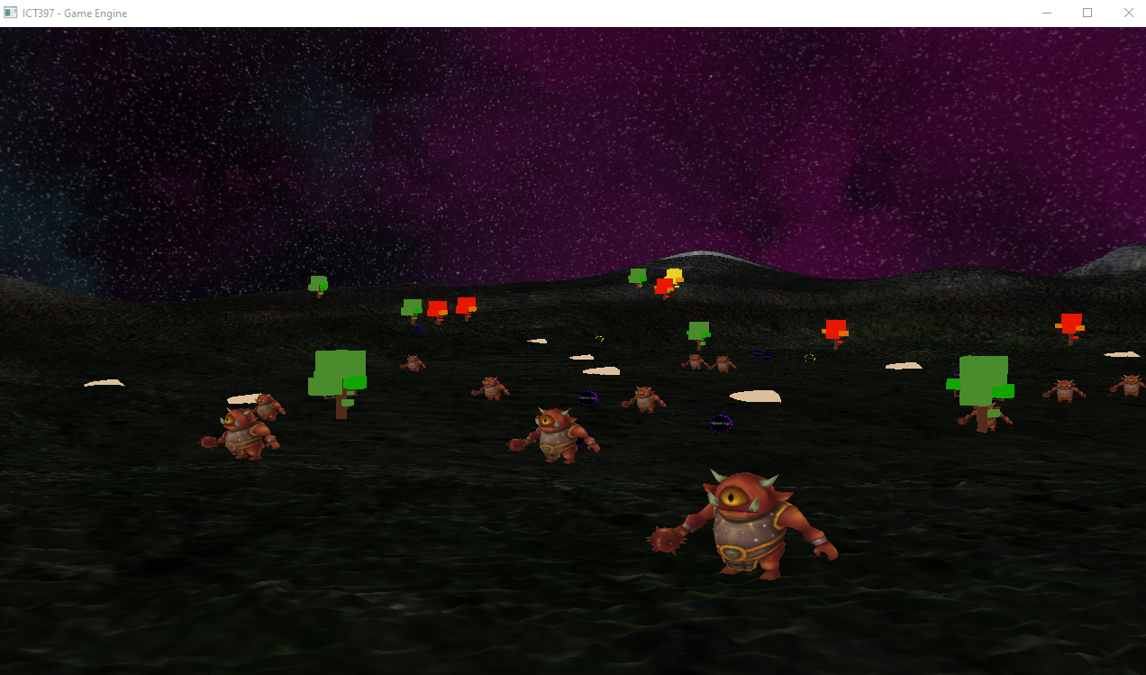

World Layout Detail #1 – Randomly placed enemies

In the current demo build of the game, 15 demon enemies are placed on the map at random positions between two values denoted in the scene1.lua script. While they aren’t free to spawn anywhere on the map (they could be if we decided to do so simply by editing the script), the fact that their positions change up slightly means that the early stages of a game will be slightly different each time.

World Layout Detail #2 – Randomly placed furnishings

In the current demo build of the game, numerous trees, tokens, and rocks are placed on the map at random positions between two values denoted in the scene1.lua script. While they aren’t free to spawn anywhere on the map (they could be if we decided to do so simply by editing the script), the fact that their positions change up leads to game feeling a bit more varied and therefore less stale.

Game Characters

Overview

When it comes to characters the only one’s present are ZOOM Girl and the horde of Demons from the “Neighbour in the Night Sky” moon.

ZOOM Girl is a silent protagonist who you never get to see because of the first-person camera, but we feel that the story characterizes her nicely as this badass female super soldier.

The Demons appear to try and kill ZOOM Girl, but they are unnamed villains and don’t have any personalities. They are described in the narrative as hellish beasts that have come to claim Earth as property of the underworld.

Creating a Character

Again, as mentioned a few times already, our character does have a back story that serves as the reason as to why the events of the ZOOM video game is occurring, but other than that we haven’t put a great deal of character building into her due to that not being a necessity of the assignment.

If we get ahead in the second assignment and have time to give her more of a prominent role of physical appearance in-game, we will do so.

Enemies and Monsters

This is how the Demon characters appear in game: 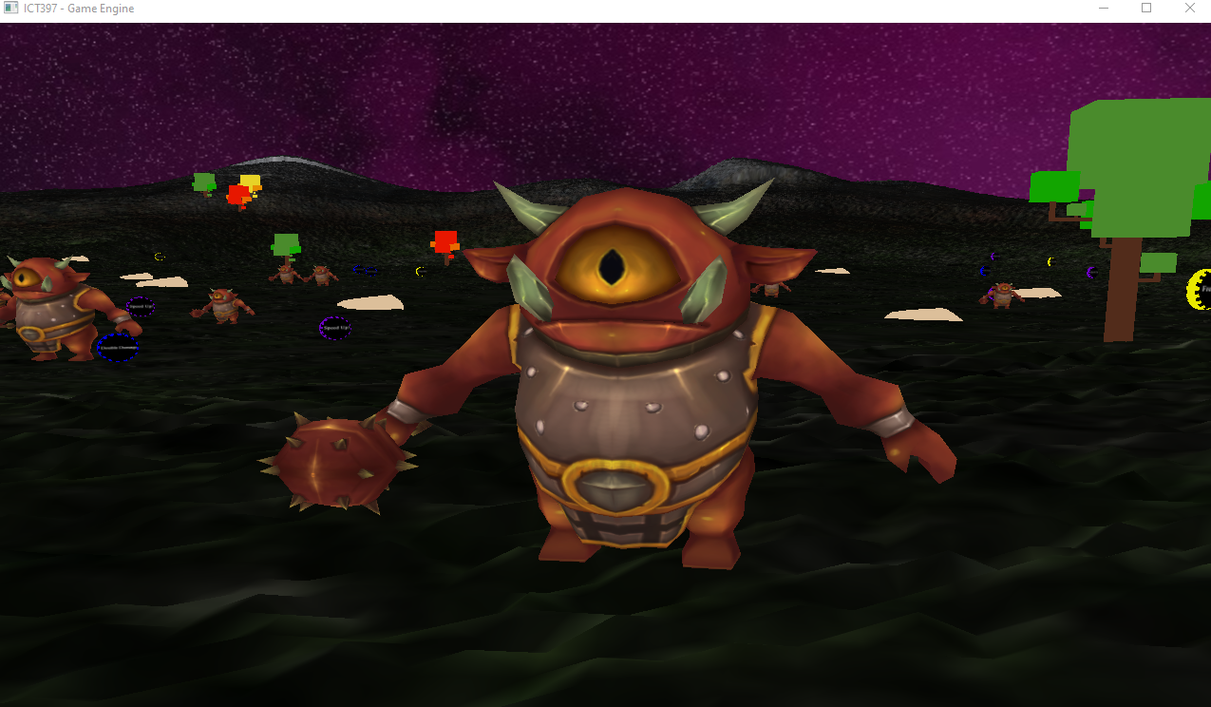

User Interface

Main Menu Screen

*DESIGN DRAFT – NOT YET IMPLEMENTED*
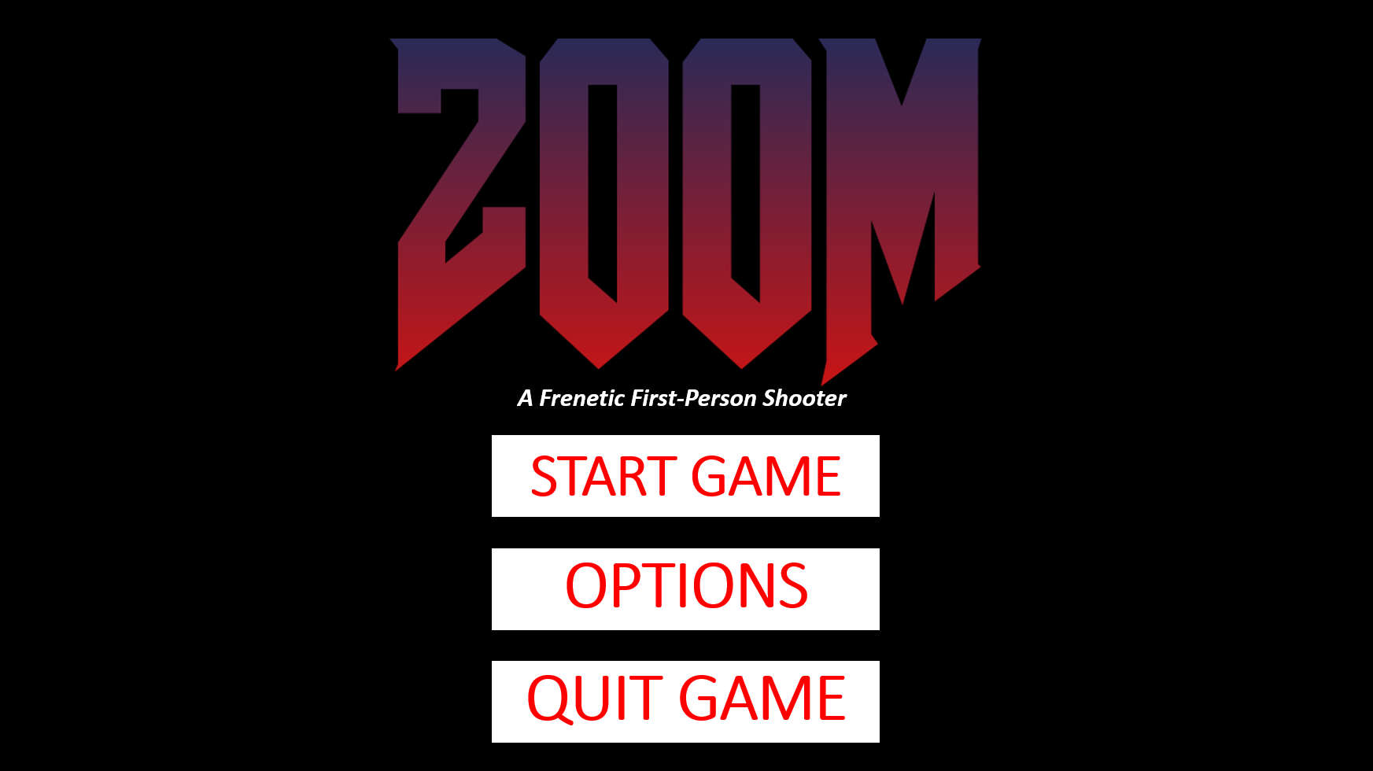

The Main Menu screen allows you to start and quit the game, as well as the ability to tinker with some of the game’s settings in the options menu.

Results Screen

*DESIGN DRAFT – NOT YET IMPLEMENTED*
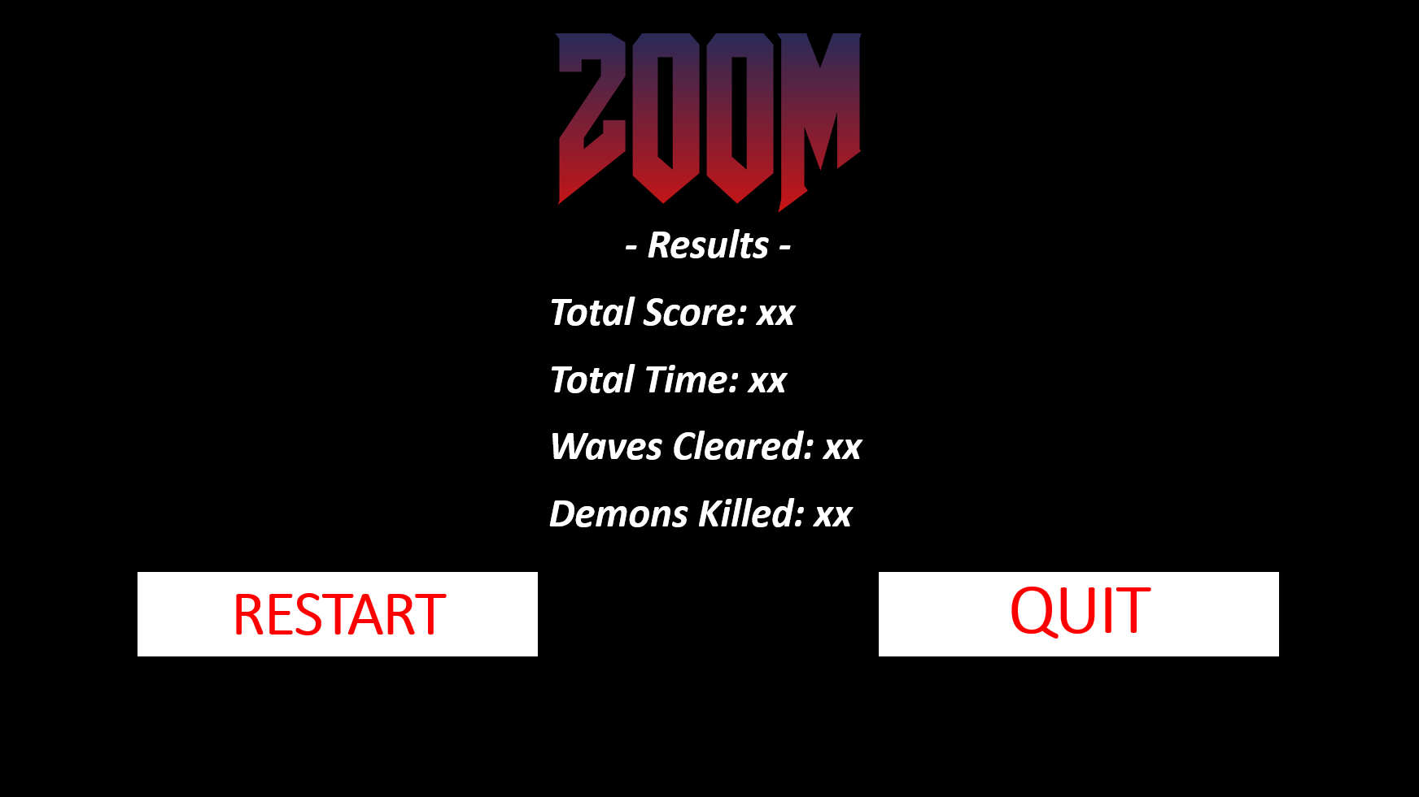

The results page appears when ZOOM Girl runs out of health. It displays the results of the last match, showing things such as the amount of waves cleared, the total points score and the amount of demons killed.

Credits Screen

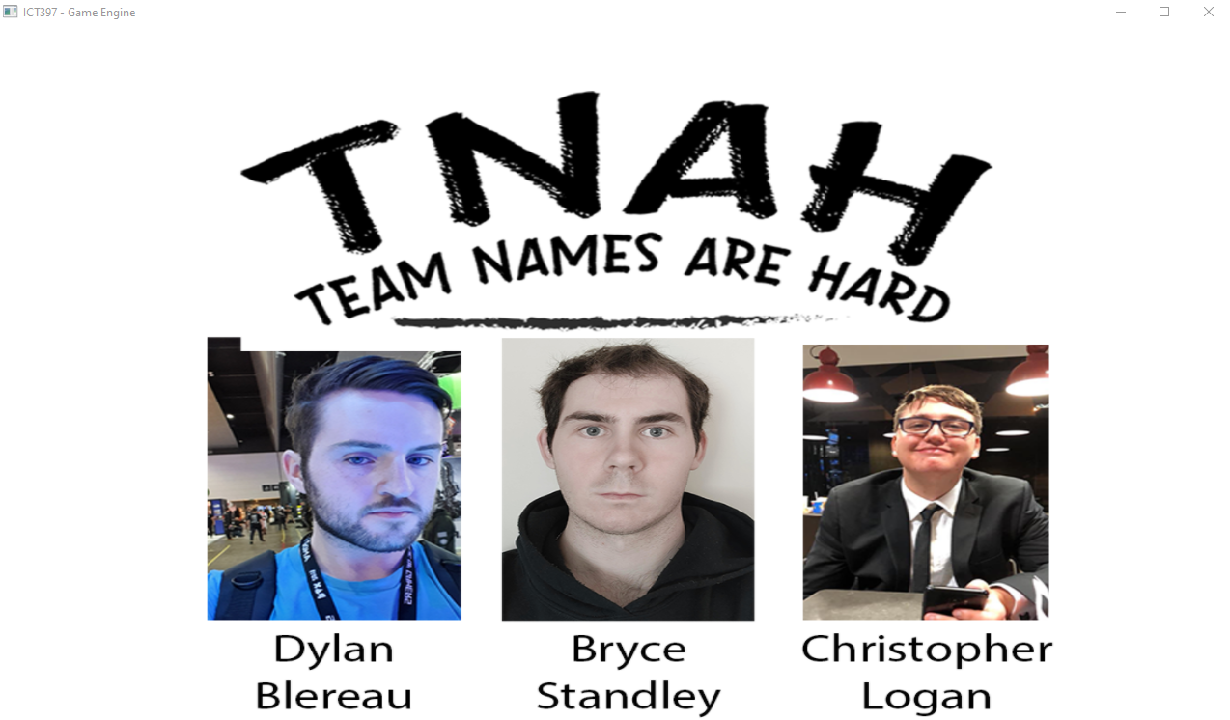

The credits screen will display when exiting out of the game. It will display the faces and names of each member of the development team. A left click on this page will close the application.

Controls Screen

*DESIGN DRAFT – NOT YET IMPLEMENTED*
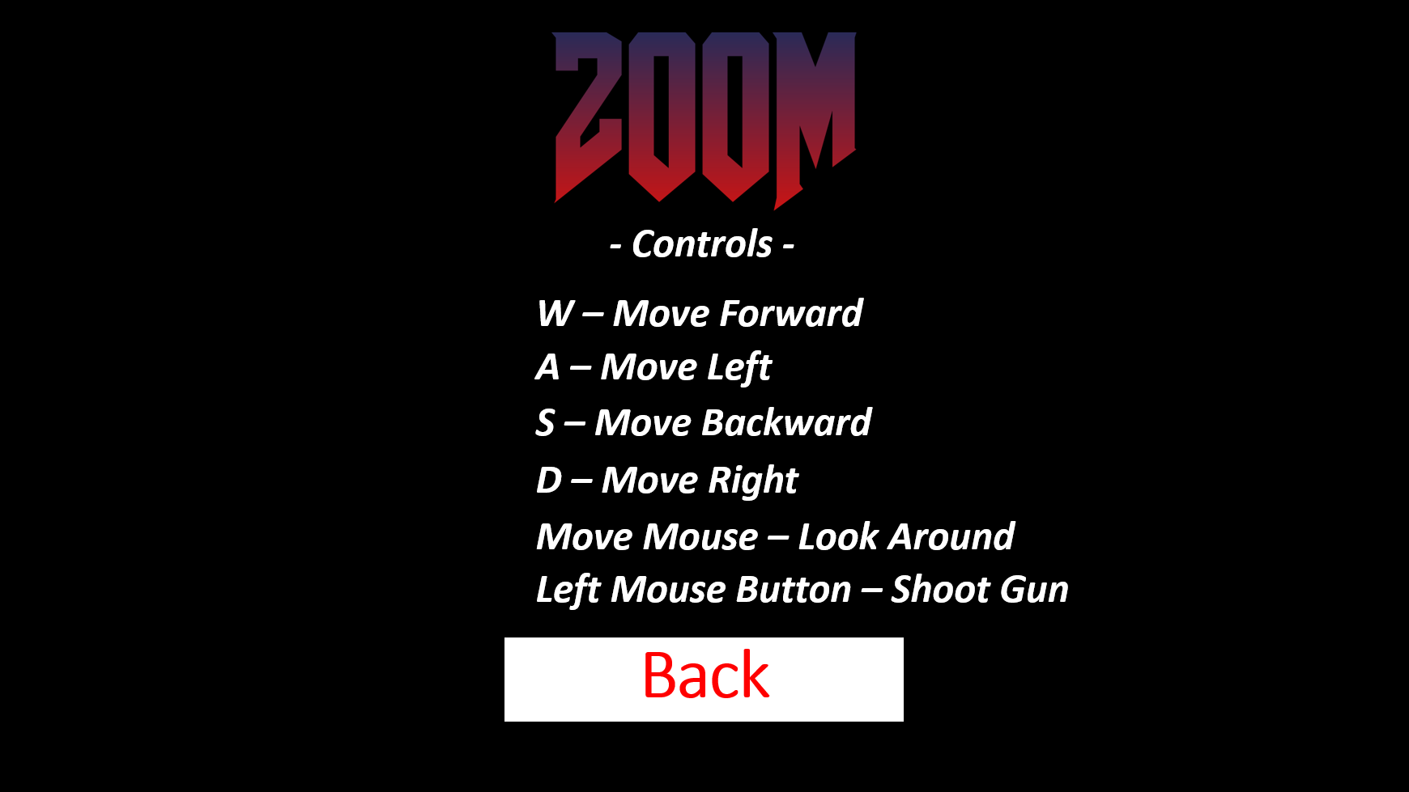

The controls page can be accessed from the options menu on the main menu and will also display in-game by pressing the ‘M’ key. It shows all the controls required to play the game

Weapons

Overview

Overview of weapons used in game.

Weapons Details #1
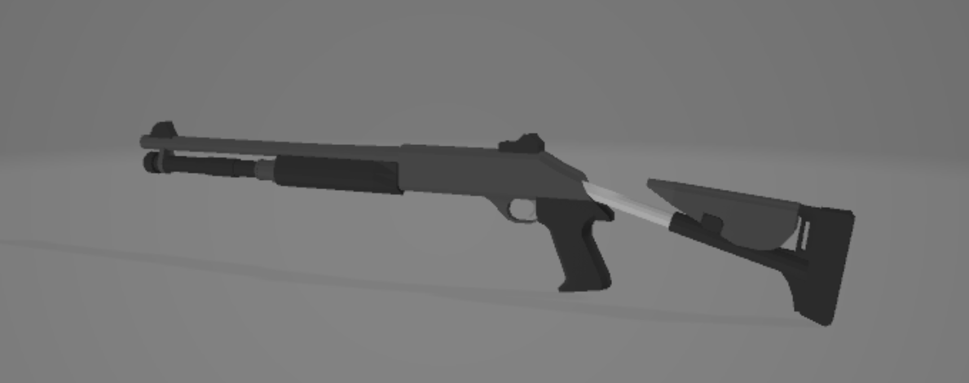

The players weapon (shotgun) is placed as a player model and positioned to be a fixed position in the players view. Currently the players weapon serves no function and is just visual.

Sound and Music

Overview

The music and sounds for ZOOM should aid in creating an epic and bombastic atmosphere. Like its inspirator DOOM, ZOOM will feature and industrial tech metal soundtrack, with accompanying sound effects for the game’s weapon, power-ups, and demons.

While none of this is currently implemented, it is our aim in assignment 2 to incorporate the following into the game.

Sound Effects

- Demon noises
- Gun sounds
- Start/End of wave alert
- Collected Token
- High Score!

Music

- Main Menu
- Level music
- End of game music

Single-Player Game

Story

ZOOM takes place on a small but dangerous moon that has mysteriously appeared in the solar system, not too far from the Earth’s moon. The people of Earth grow increasingly anxious and suspicious of this new moon, but they continue to live out their everyday lives. A few days after the moon’s arrival, Demon’s start appearing around the globe, attacking civilians, and claiming Earth as property of the underworld. In retaliation to the attack on Earth by the Demons, the United Nations enlist the help of ZOOM Girl, a biological superhuman who they see as humanity’s only hope of eradicating the demonic spawn. ZOOM Girl is quickly sent to the Demon moon now known as the “Neighbour in the Night Sky” with a simple mission – kill as many Demons as you possibly can.

Core Gameplay

The core gameplay of ZOOM consists of the protagonist ZOOM Girl running and gunning around the map, killing endless hordes of demons as they constantly spawn around the map. A greater summary of the gameplay experience can be seen below in “Modes of Play”.

Modes of Play

Attack Waves

When it comes to the gameplay of ZOOM, you’ll quickly come to learn of how simple yet enjoyable it is. As ZOOM Girl your job is to run around the sizeable map killing all demons who get in your way.

The Demon horde attack ZOOM Girl in waves, with more and more spawning each subsequent wave. With her trusty shotgun and the assistance of handy power-ups such as double damage and infinite ammo, ZOOM Girl’s mission is clear, get through as many waves before you are too injured to continue. In layman’s terms, once ZOOM Girl’s health bar reaches zero, the game session ends.

The current wave number and remaining number of demons will be displayed on the screen during each wave, giving ZOOM Girl enough intel about how things are tracking. The end of a wave will also provide a short breather from enemies, giving you time to position yourself for the next round and have a quick look for any power-up tokens that may still be hovering around.

Power-up tokens are handy timed upgrades that grant ZOOM Girl with abilities such as double damage or double points (see 2.2.2 regarding the Points System). These tokens appear at random, sometimes spawning after the death of an enemy, while other times they may just spawn in the overworld for no reason at all (see 2.5.3 for further information on Power-ups).

ZOOM Girl is only given a limited supply of ammo for her shotgun at the beginning of the game. Thanks to ZOOM Girl’s futuristic suit, both her ammunition and health will replenish at slow rate without the need for ammo and health kits. Finding ammo and health refill tokens remain the best way for you to get your health and ammo back to a comfortable level.

Quick Rest

The 15 second period between waves is known as the “Quick Rest” period. This time should be used checking the overworld for any power-up tokens, while also providing you enough time to find a spot where you want to attack from in the upcoming round.

Scoring

When it comes to scoring, we believe points will be accrued for doing the following:

- Killing a Demon
- Clearing a wave
- Collecting a power-up token

The overall math for the scoring system hasn’t been determined, however it will be provided in this document when decided upon.

Killing a Demon
The points value for killing a demon will likely consider the wave in which it was killed in, as higher waves will mean stronger Demons. *Still to be determined*

Clearing a Wave
The points value awarded to the player at the end of a wave will likely be determined by how difficult the wave was. For example, waves 1-10 may be considered easy, receiving less points in comparison to waves 11-20 which are deemed of medium difficulty.

Because we haven’t decided on difficulty scaling between sets of waves, the points for completing a wave are still to be determined.

Collecting a Power-Up Token
Grabbing a Power-Up Token will provide the same amount of points no matter what round they are acquired in. If a Free Hit or Double Points Token has been collected the player will also receive points from those also.

- Free Hit token when collected will provide the default token collection points, as well as the points for ending the round and killing the remaining Demons.
  - For example, if the Free Hit token is collecting while there are 8 Demons remaining in a round, then the player will be awarded the points for killing those 8 demons and ending the round, on top of the points already gained for grabbing the token.
- Double Points will provide the default token collection points, as well as double points for all the Demons killed and waves ended in the given 30 seconds.

Again, because we don’t know how points scaling will work yet, so the overall point values will be determined shortly.

Game Flow

Note: Only the credits screen is implemented in this demo.
SPLASH SCREEN → MAIN MENU → PLAY → RESULTS SCREEN → CREDITS SCREEN

Splash Screen
Upon booting the game, a basic splash screen will appear with the development team logo, alongside the names of the members of the development team.

Main Menu Mode
Before launching into the gameplay experience of ZOOM, you will first be taken to the main menu. This basic interface will provide with the options to start/quit the game, as well as the option to tinker with the game’s settings. *Adjustable settings to be determined.

Play Mode
This is the main gameplay mode, as described in section 2.1 above.

When the player is hit the game ends. If the player has a high score, he will be able to enter in 3 initials.

Results Screen Mode
When ZOOM Girl finally falls to her demon enemies and her health bar depletes to zero, you will be shown the results screen, which highlights your overall score, as well as how many demons you killed and waves you cleared.

Credits Screen Mode
Exiting out of the game by pressing X will move you to the credits screen. It displays the faces and names development team (as per assignment requirements).

Power-Ups!

Throughout the game, tokens will appear in the game world for a short period of time. Collecting one will grant ZOOM Girl a handy upgrade such as double damage output from her trusty shotgun, or a short-timed speed boost that will make it easier to run around the map and eviscerate the demon foe.

*Token designs subject to change*
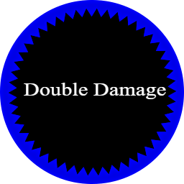 | Double Damage Token  When collected, the double damage token will give ZOOM Girl double damage output with her shotgun for 30 seconds.
 | Ammo Refill Token  When collected, the ammo refill token will fully replenish shotgun ammunition.
 | Speed Up! Token  Zoom Girl already moves fast but collecting a speed up token will add a 1.5x multiplier to her speed for 30 seconds.
 | Health Refill Token  When collected, the health refill token will fully replenish ZOOM Girl’s health meter.
 | Free Hit Token  When collected, this token will end the current wave, eliminating all remaining Demons in the process.
 | Double Points Token (Allows for the user to earn double points for 30 seconds)  When collected, the double points token will see double points earnt for killing Demons, finishing a wave or grabbing additional tokens for a period of 30 seconds.

Gameplay Length

In terms of gameplay length, we don’t see ZOOM being an overly long game, with its length dependent largely on the skill level of the player.

Because of its wave-based nature, ZOOM sessions could last a couple minutes or perhaps 10-15 minutes.

Victory Conditions

The wave-based nature of ZOOM means that there aren’t any traditional victory conditions. While we may add a level cap to the game in the future, we currently envisioning the gameplay continuously ramping up in difficulty until the player fails the run and ends the gameplay session. Because of the game keeping score of your gameplay session, high scores could be considered the victory condition.

AI Features

The Demons by the time assignment 2 is submitted will have basic AI, they will attack ZOOM Girl in groups when others are around and will try to chase her down. If she manages to get ahold of a double damage token, they may even get scared and attempt to run away while the token wears off.

World Editing

Overview

There is not dedicated world editing through a dedicated world editor, however scripts provide a way for the user to change and customize aspects of the world such as the terrain, skybox, and object placement.

World Editing Detail #1 – Customisable Terrain!

Using the terrain.lua script, you can customize aspects of the terrain such as its size, scale, textures, detail map and shaders. You can even change the heightmap used entirely, allowing you to make new maps simply by providing it a different heightmap.

World Editing Detail #2 – Customisable Skybox!

While we think our skybox looks neat, we have provided via the skybox.lua script the ability to change the images that make up the skybox. This means that you can add in any skybox that you want by simply providing images to the paths that correspond to each skybox face.

World Editing Detail #3 – Customisable Object Placement!

We could have just provided a concrete amount of objects and placed them at designated places on the map, but we thought it’d be nice to provide the user the freedom to place as many objects of any type that they like anywhere on the map. Through the scene1.lua script you can add in any model you like into the game world and can make use of the loops to randomly place them around the map. If you prefer to place them somewhere particular each time, all you need to do is provide the positions. Granting the user this level of freedom essentially makes this script the main level editing tool.

Extra Miscellaneous Stuff

Overview

Just a space to explain miscellaneous stuff we are messing around with.

Junk I am working on…

Bounding Boxes
Currently the engine uses a simple sphere distance method to approximate the position the player is compared to a given game object in the scene. As a work in progress, proper bounding boxes being generated for an object and more accurate collision detection will be implemented into the engine. The use of bounding boxes adds a lot of complexity to the collisions system that was out of scope for this version of the engine.

